1. Upload customer_demographics_geo.csv dataset into Watson Studio. Dataset is provided in this folder.  
   [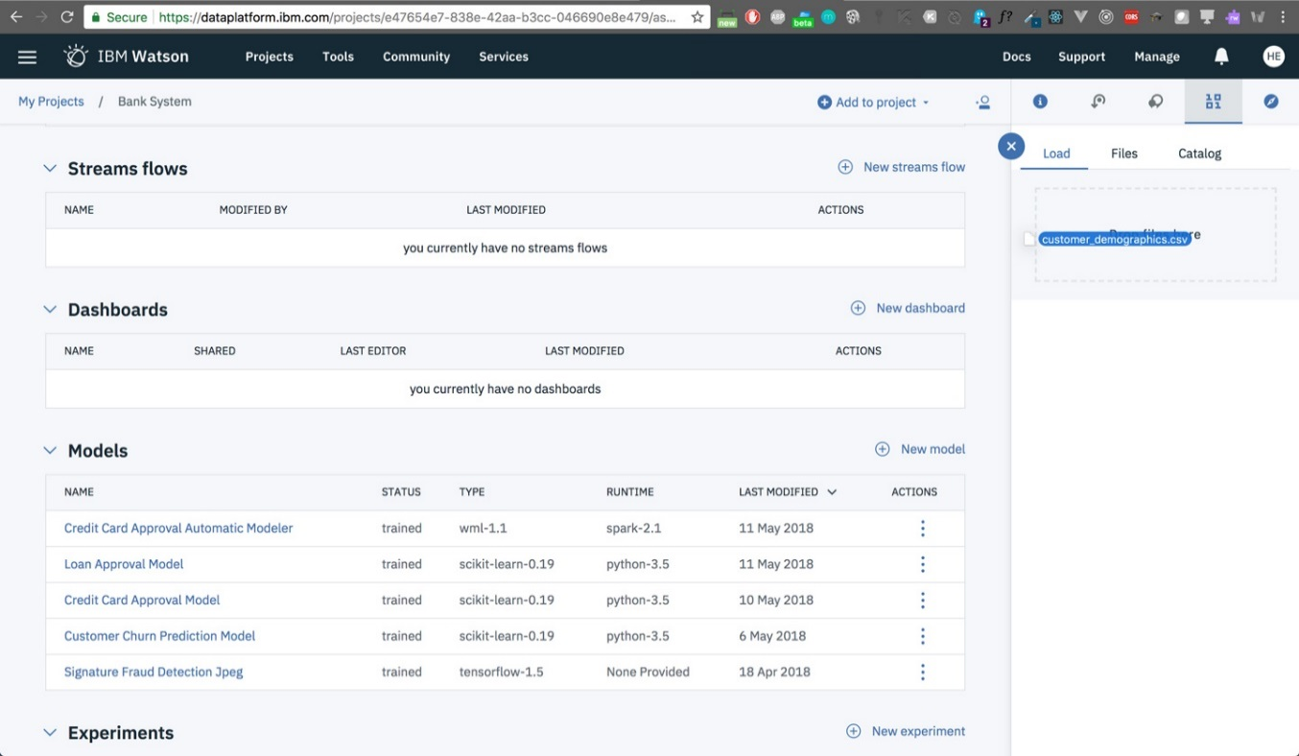](https://github.com/HebaNAS/IBM-Watson-Studio-Enablement/blob/master/06-CustomerDemographicsDashboard/imgs/1.jpg?raw=true)
2. From Watson Studio's main dashboard, select **New Dashboard** from Dashboards panel.  
   [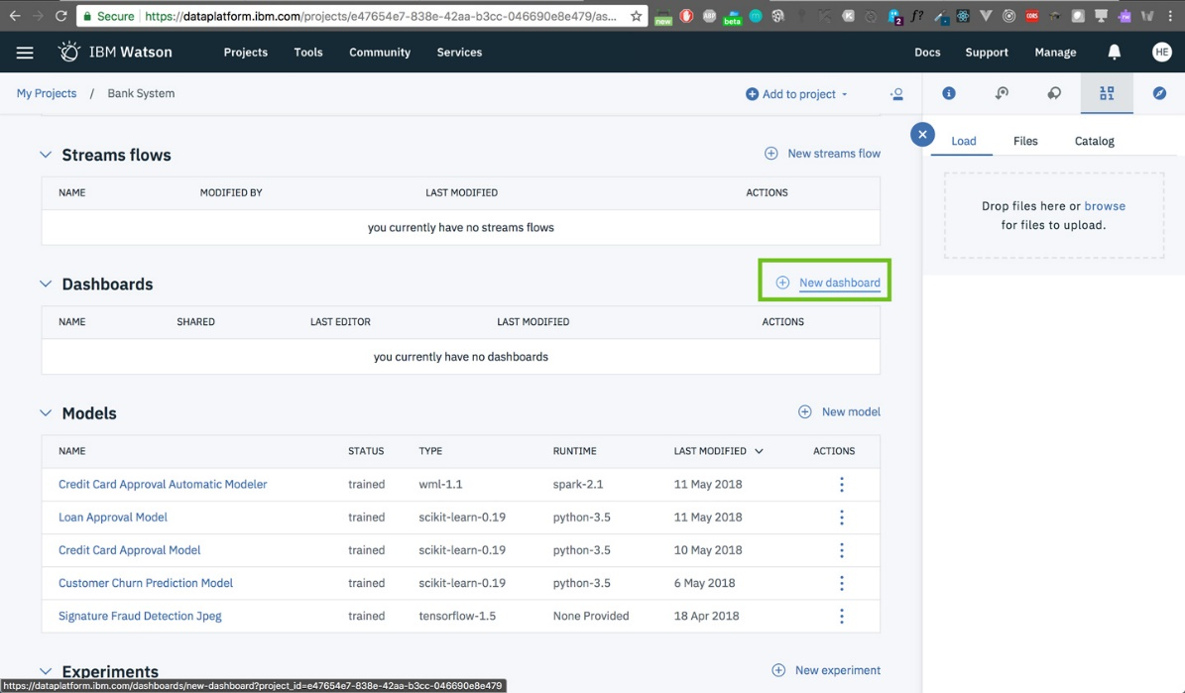](https://github.com/HebaNAS/IBM-Watson-Studio-Enablement/blob/master/06-CustomerDemographicsDashboard/imgs/2.jpg?raw=true)
3. Type a name for your dashboard. Make sure you have a dashboard analytics service instance running and selected, if not you'll be prompted to create one then reload to select it. Click **Save**.  
   [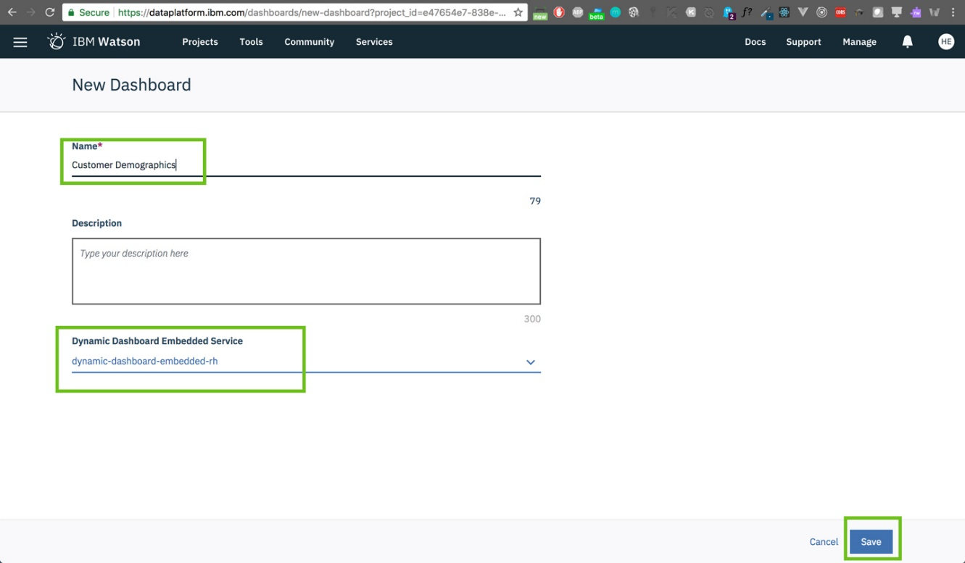](https://github.com/HebaNAS/IBM-Watson-Studio-Enablement/blob/master/06-CustomerDemographicsDashboard/imgs/3.jpg?raw=true)
4. Select the template you wish to create, here I used a tabbed template and this page layout and click OK  
   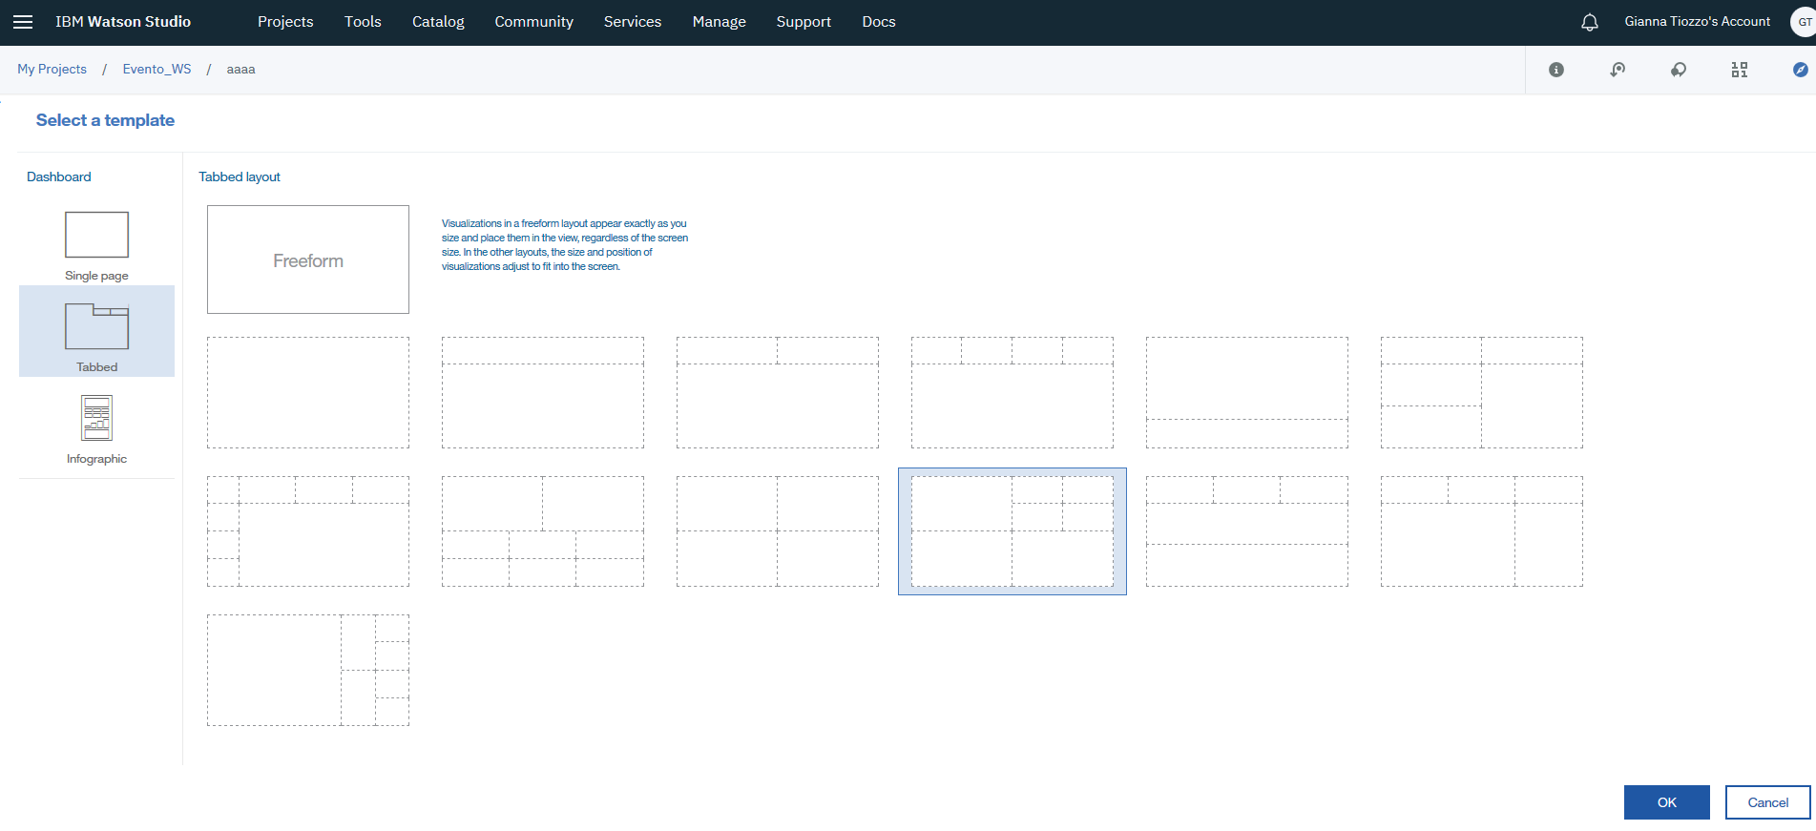
5. Select a source for the data that will be used.  
   [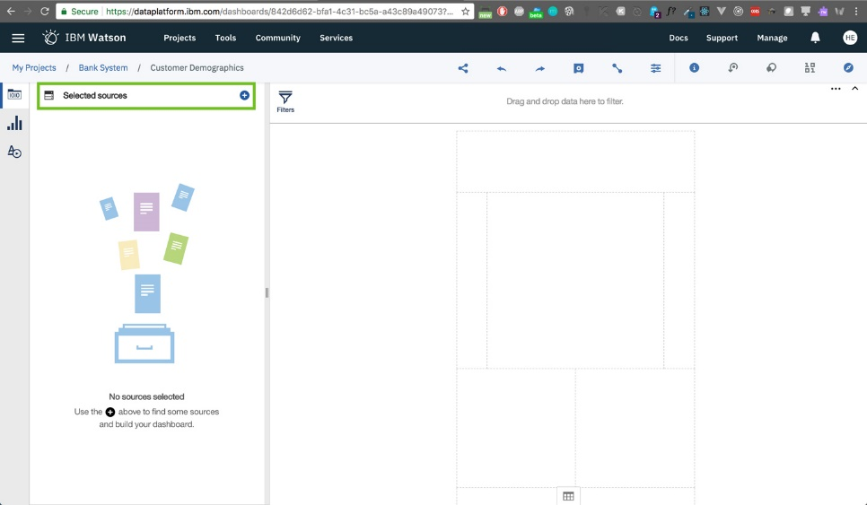](https://github.com/HebaNAS/IBM-Watson-Studio-Enablement/blob/master/06-CustomerDemographicsDashboard/imgs/6.jpg?raw=true)
6. We'll select our customer_demographics_LatLong-2 dataset and click **Select**. Note that the names shown in the image may be different from what you have.  
   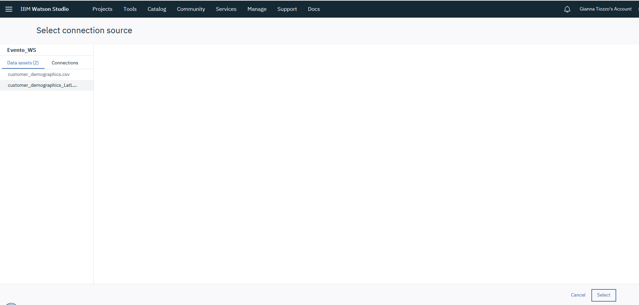
7. Click on the dataset to expand it.  
   
8. We now see all the rows.  
   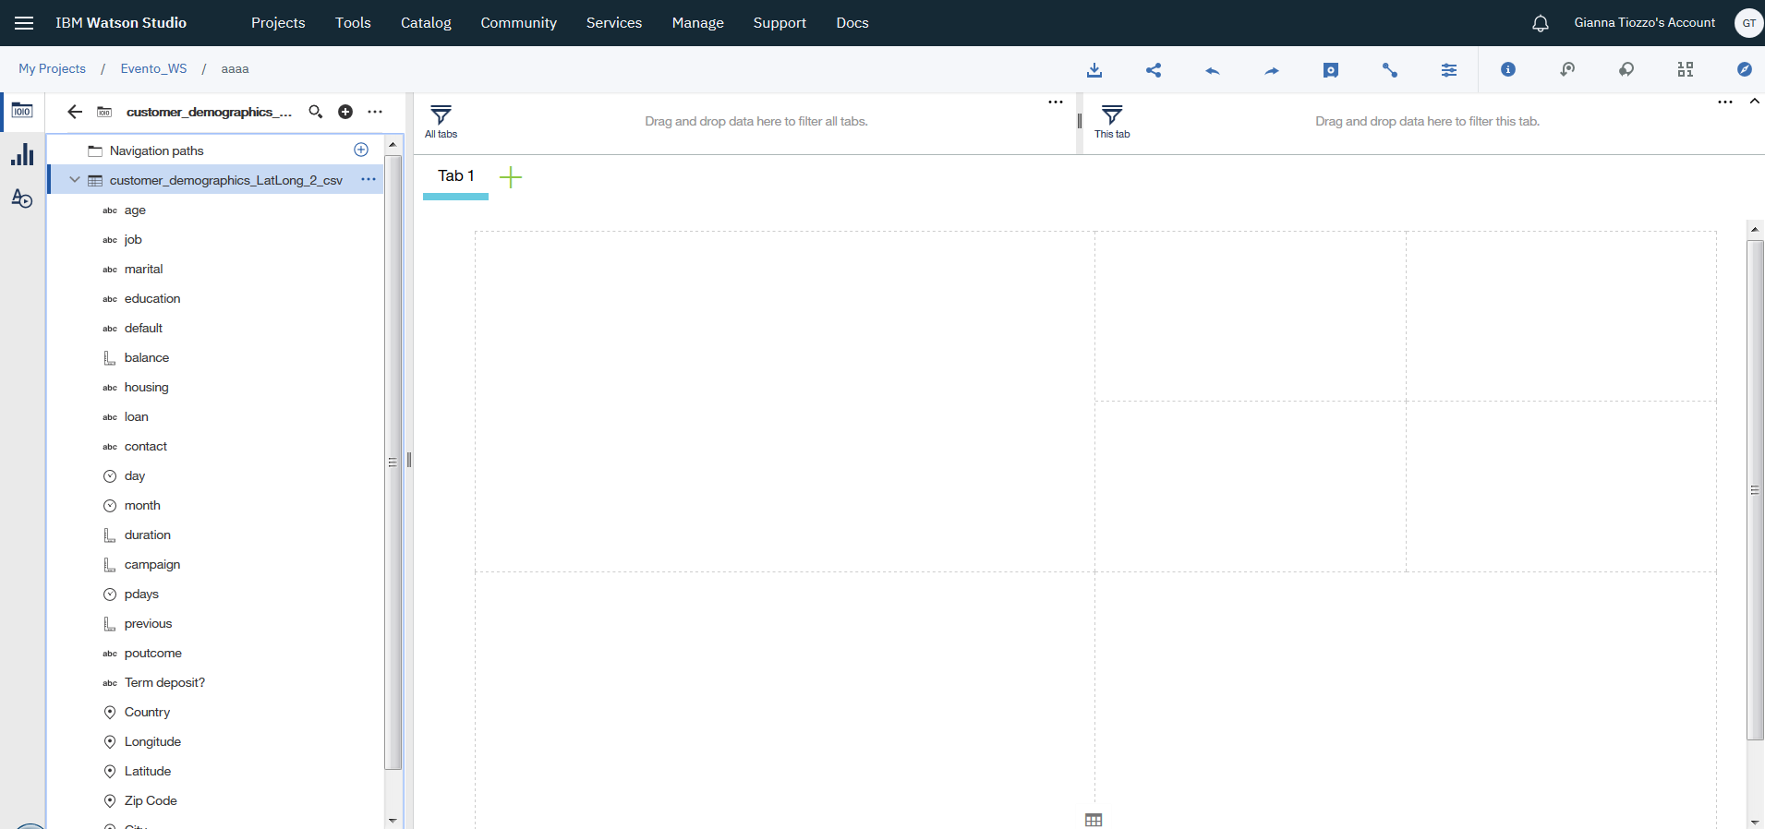
9. Let's select columns for a visualization. You can select multiple columns by pressing Ctrl or Cmd while selecting the columns. Here, I selected job and balance. Drag and drop your selected columns to where you want to place them on the template.  
   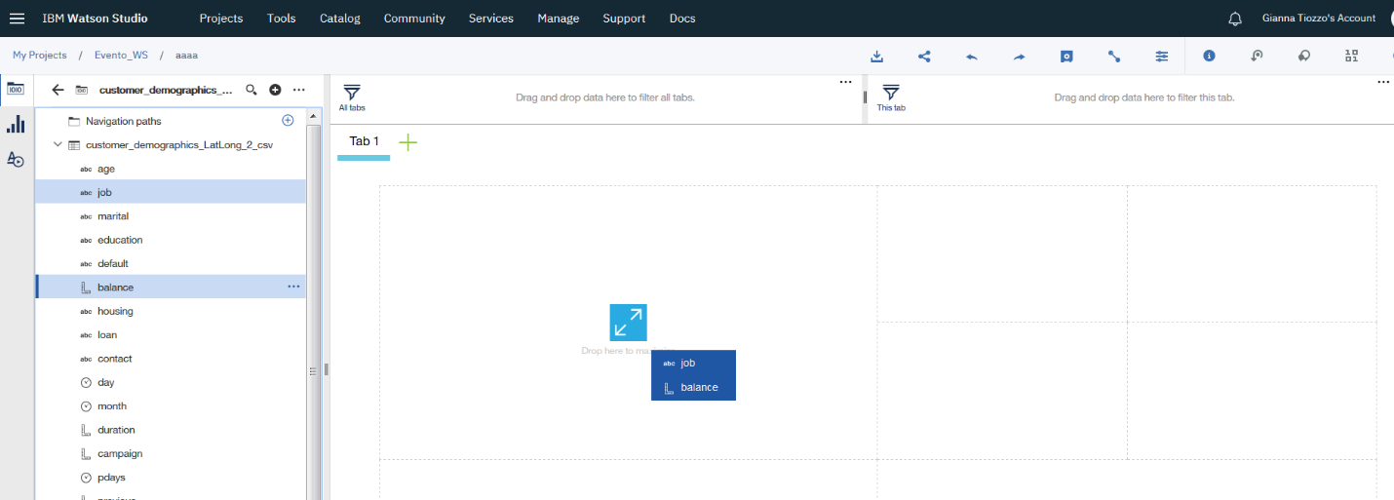
10. A visualization will be automatically picked for you, based on the data in the columns you selected. Here a **Columns Chart** was picked.  
    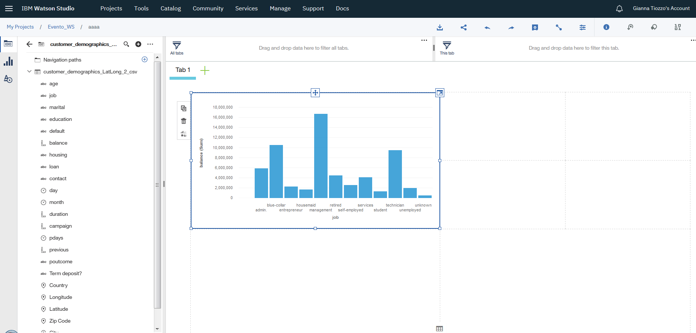
11. If you need to edit the visualization, click on the crossing arrows on top of the visualization and a side panel will appear. Click on the visualization image as shown below.  
    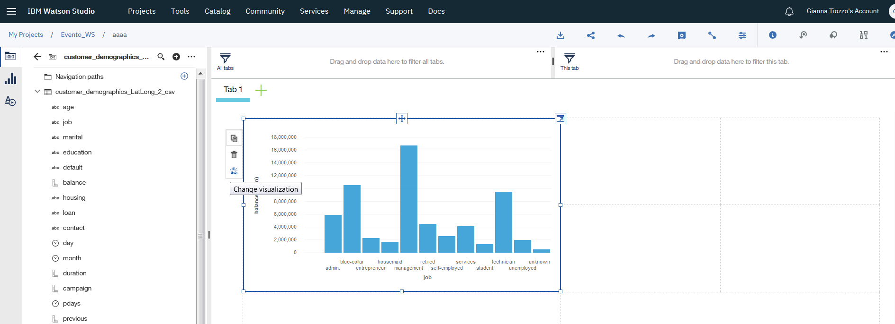
12. To select another visualization method, select one from the listed options. Here, I wanted more customization for the current visualization so click on **More**.  
    [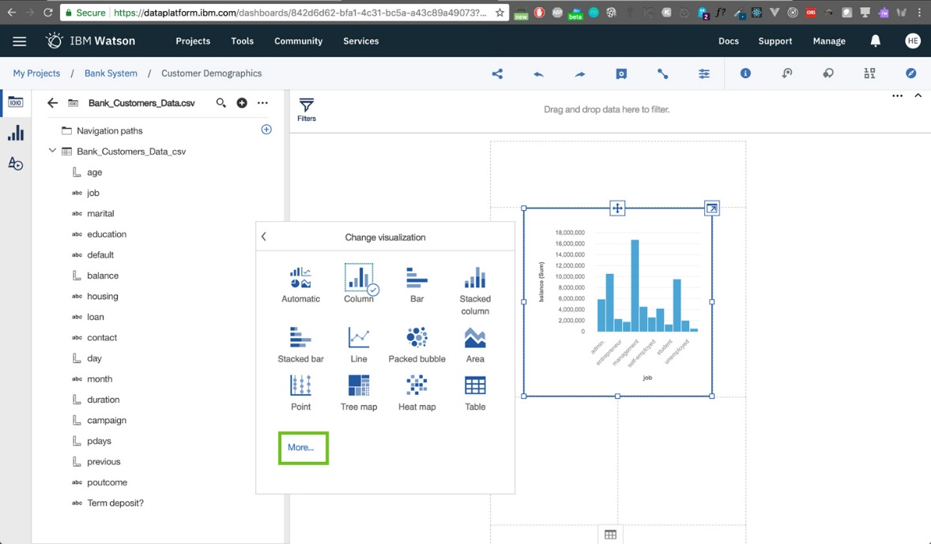](https://github.com/HebaNAS/IBM-Watson-Studio-Enablement/blob/master/06-CustomerDemographicsDashboard/imgs/14.jpg?raw=true)
13. Confirm the Column Chart option to proceed.  
    [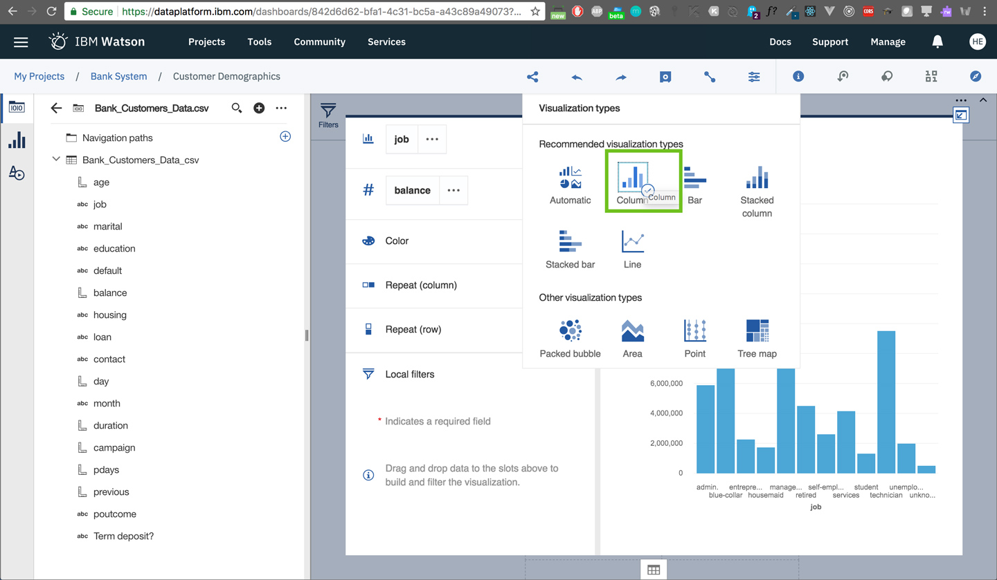](https://github.com/HebaNAS/IBM-Watson-Studio-Enablement/blob/master/06-CustomerDemographicsDashboard/imgs/15.jpg?raw=true)
14. Here, we'll select the method of summarization of the balance column. It has continuous values and they were originally represented as a sum.  
    [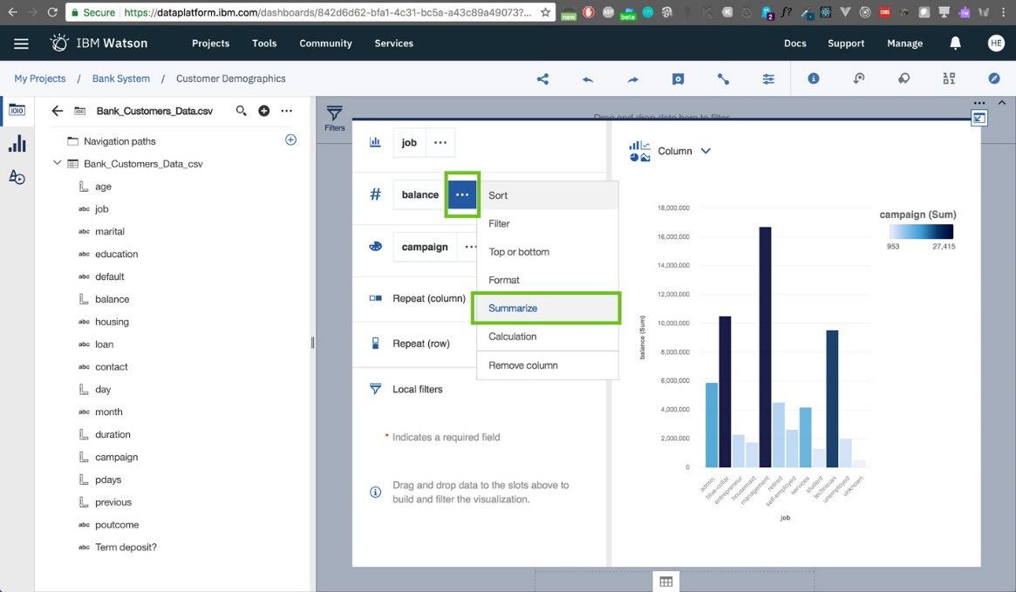](https://github.com/HebaNAS/IBM-Watson-Studio-Enablement/blob/master/06-CustomerDemographicsDashboard/imgs/16.jpg?raw=true)
15. Let's change the summary into **Average**.  
    [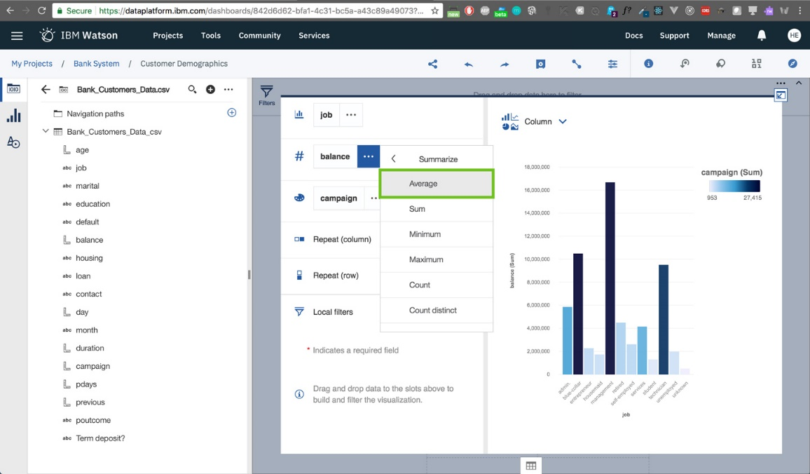](https://github.com/HebaNAS/IBM-Watson-Studio-Enablement/blob/master/06-CustomerDemographicsDashboard/imgs/17.jpg?raw=true)
16. The change has been reflected.  
    [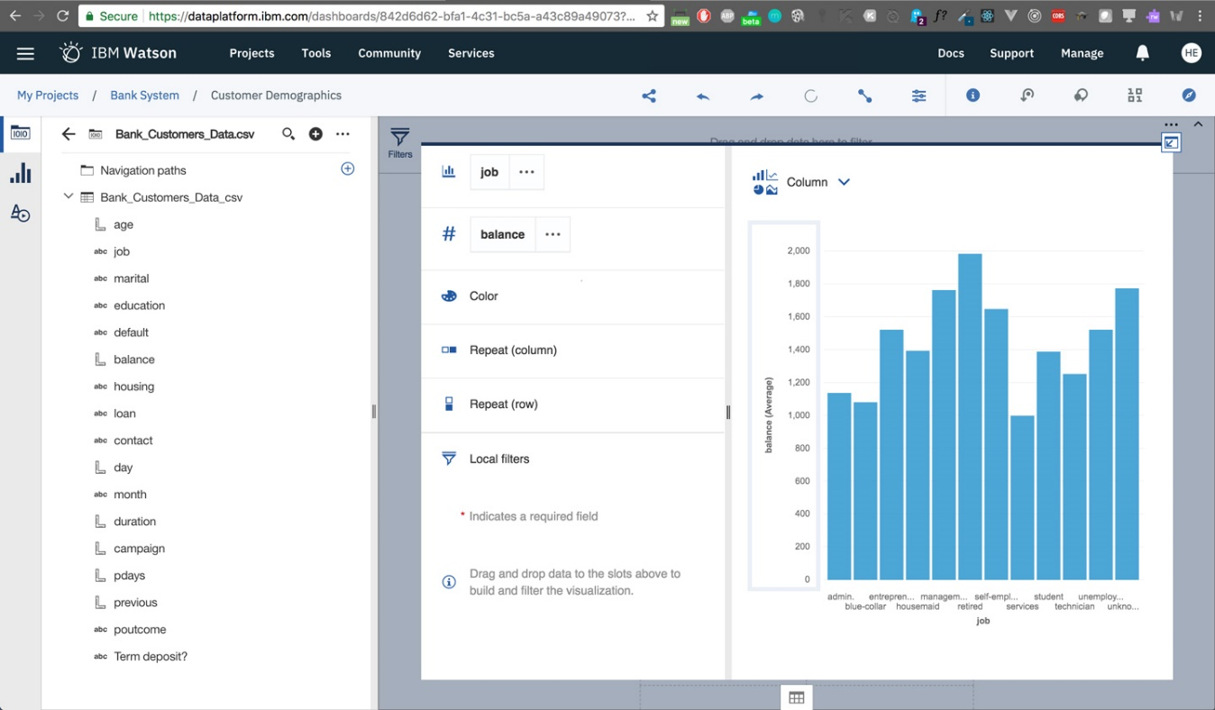](https://github.com/HebaNAS/IBM-Watson-Studio-Enablement/blob/master/06-CustomerDemographicsDashboard/imgs/18.jpg?raw=true)
17. Now for making a better UI, let's choose a way to color the columns. Here, I picked coloring the columns according to the distinct categories of jobs we have, so I inserted job column into the color property.  
    [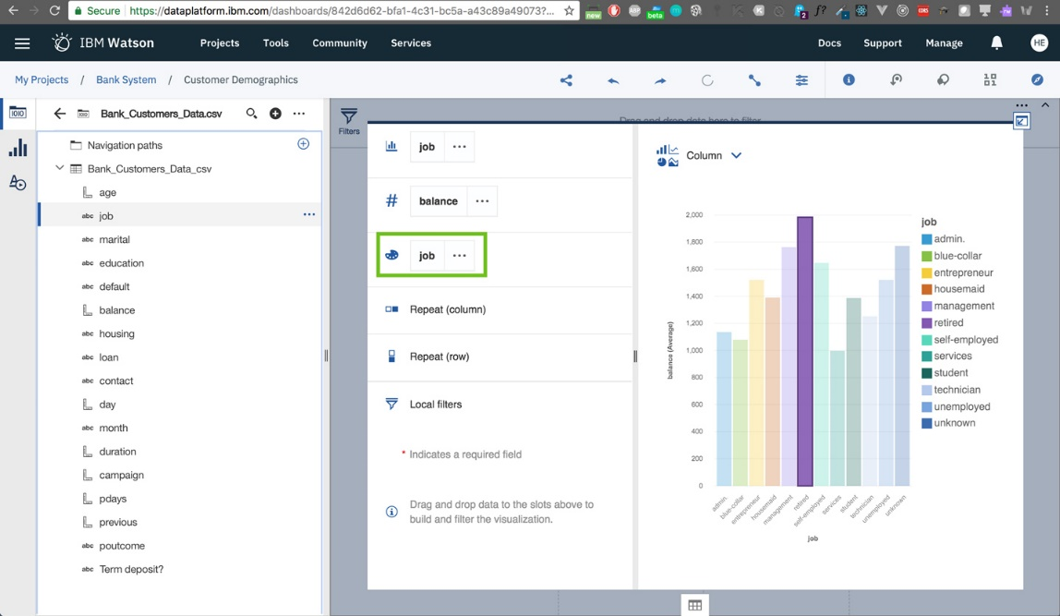](https://github.com/HebaNAS/IBM-Watson-Studio-Enablement/blob/master/06-CustomerDemographicsDashboard/imgs/19.jpg?raw=true)
18. Let's enter a title for our visualization. Choose the properties icon on the right bottom.  
    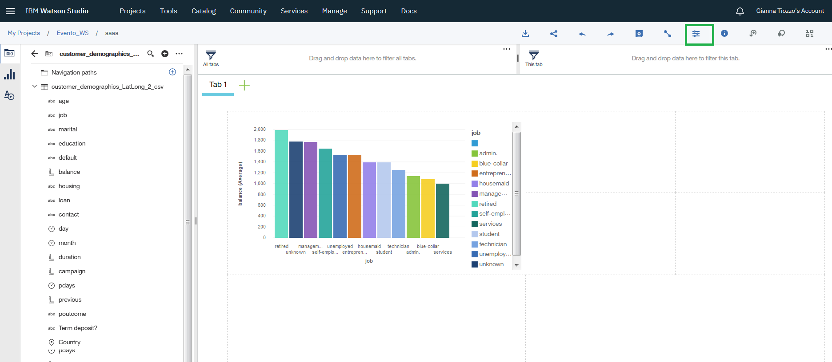
19. Select the general tab on the right-panel and select Show Title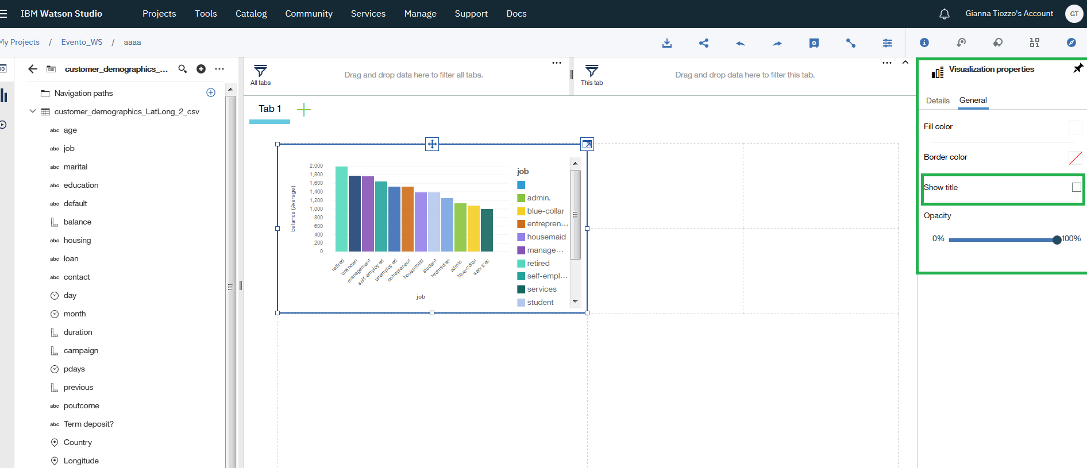
20. Adding a title to the graphic.  
    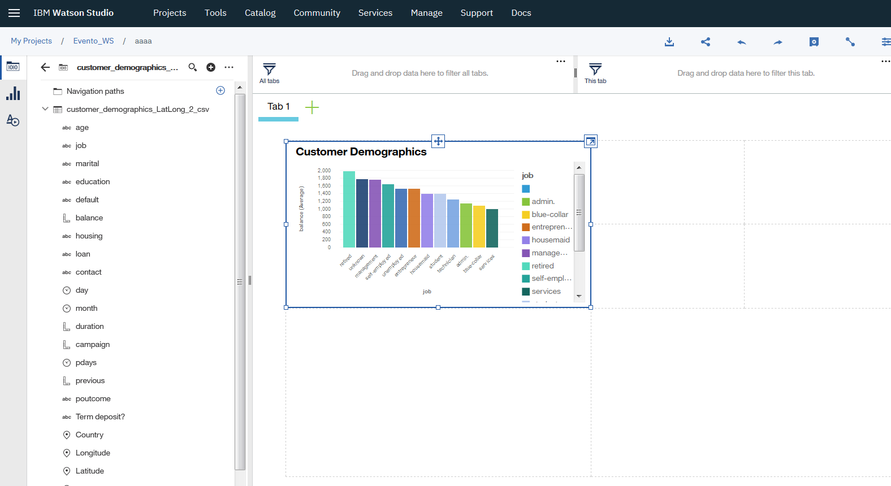
21. You can choose **Properties** from the top toolbar to change the properties of any object in the visualization. Here I chose Visualization properties.  
    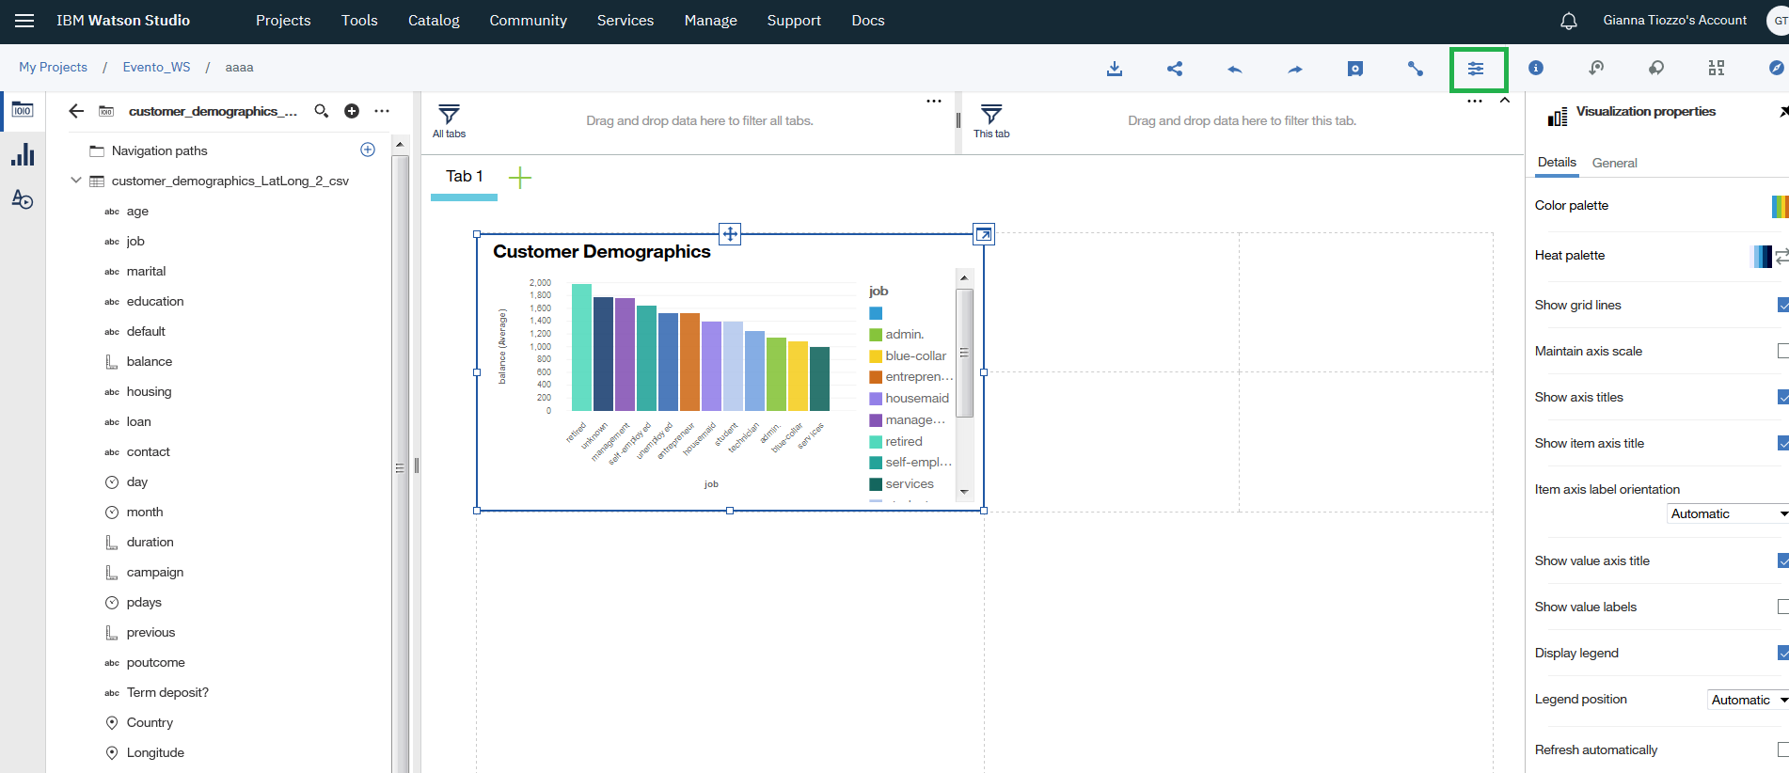
22. Changing the color palette, legend position,…  
    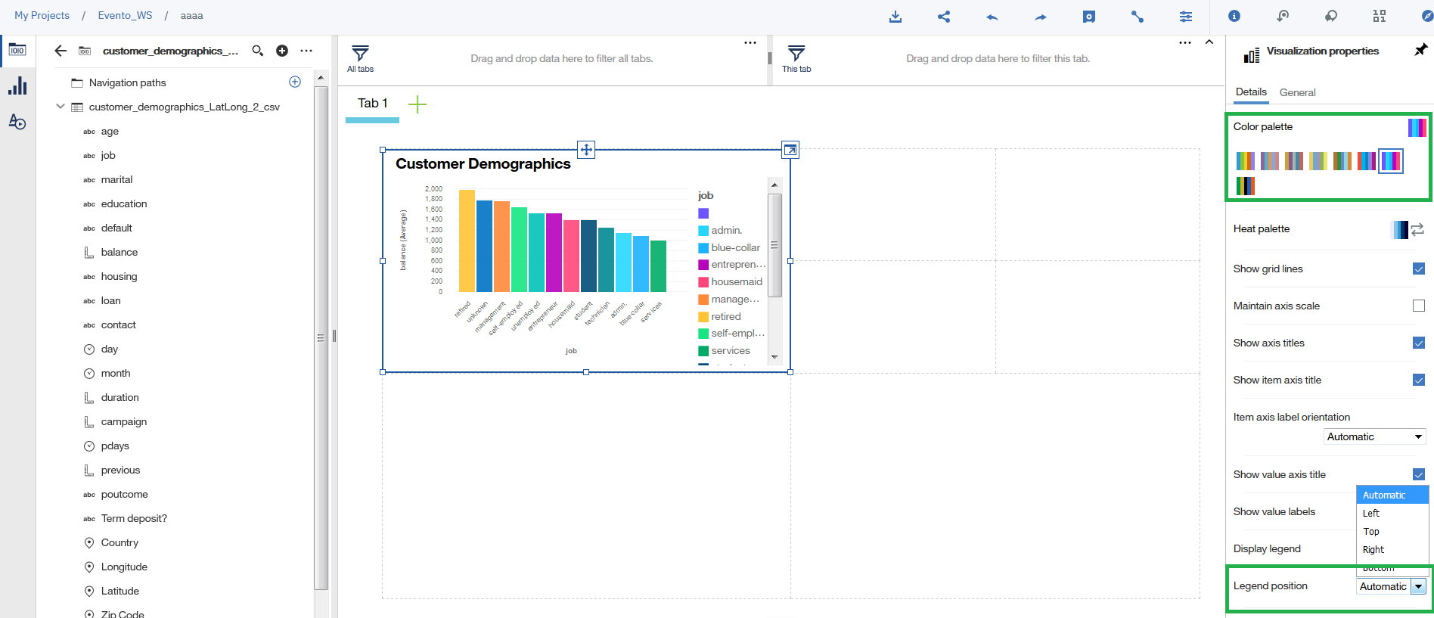
23. You can choose different themes for the visualization. Let's switch to a **Dark** theme.

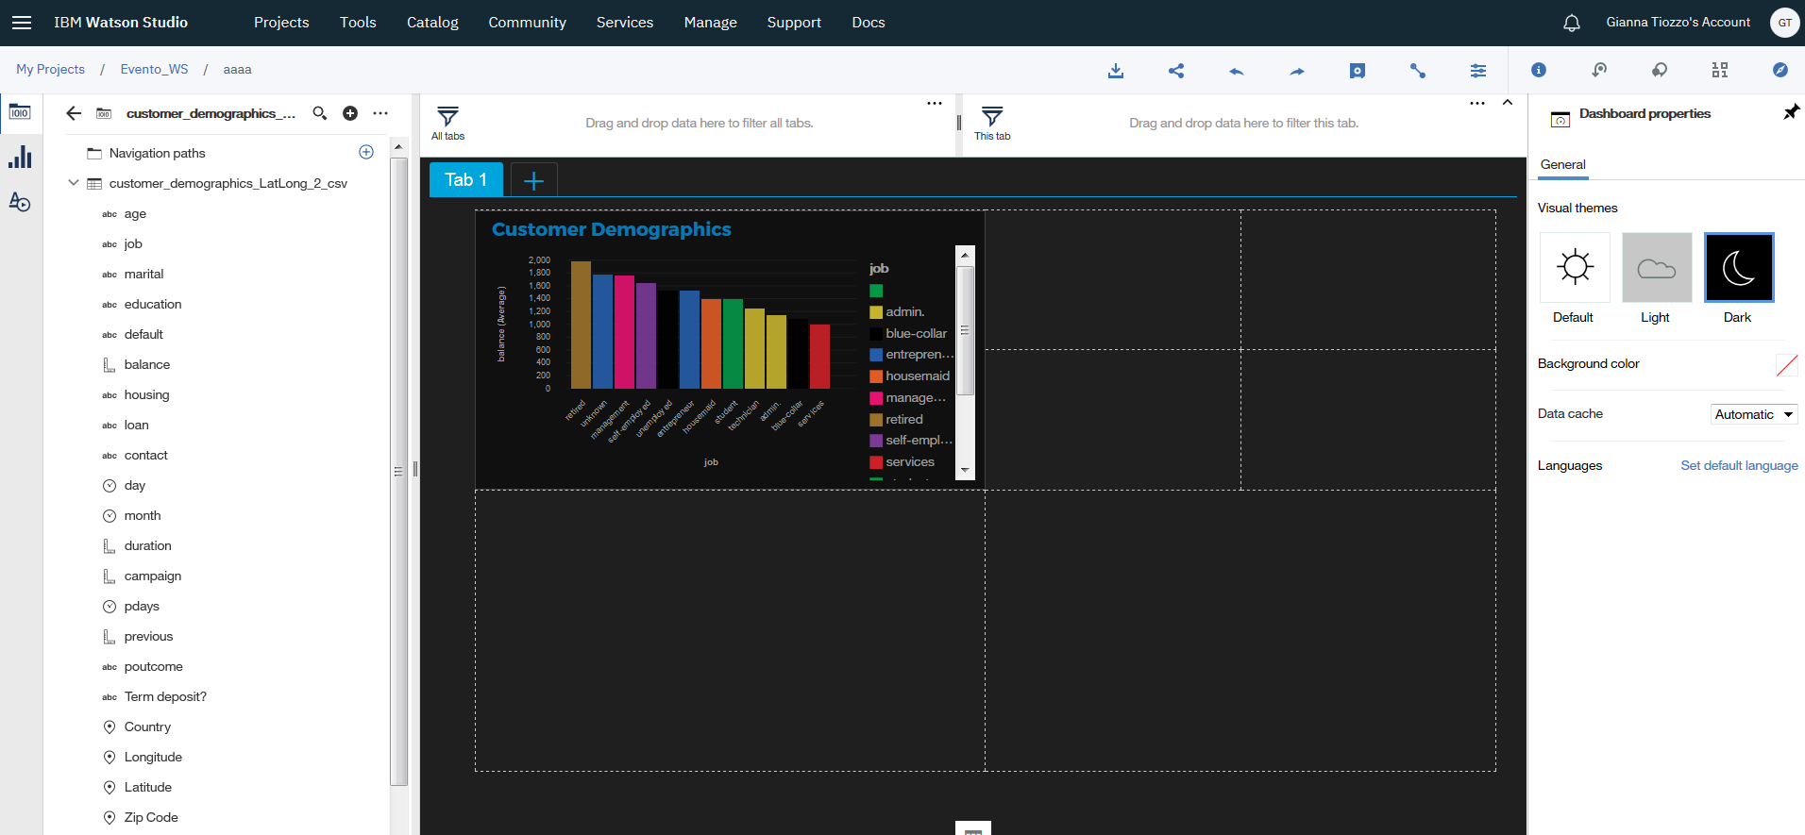

1. Let's create another visualization. This time let's pick the marital column from our dataset.  
   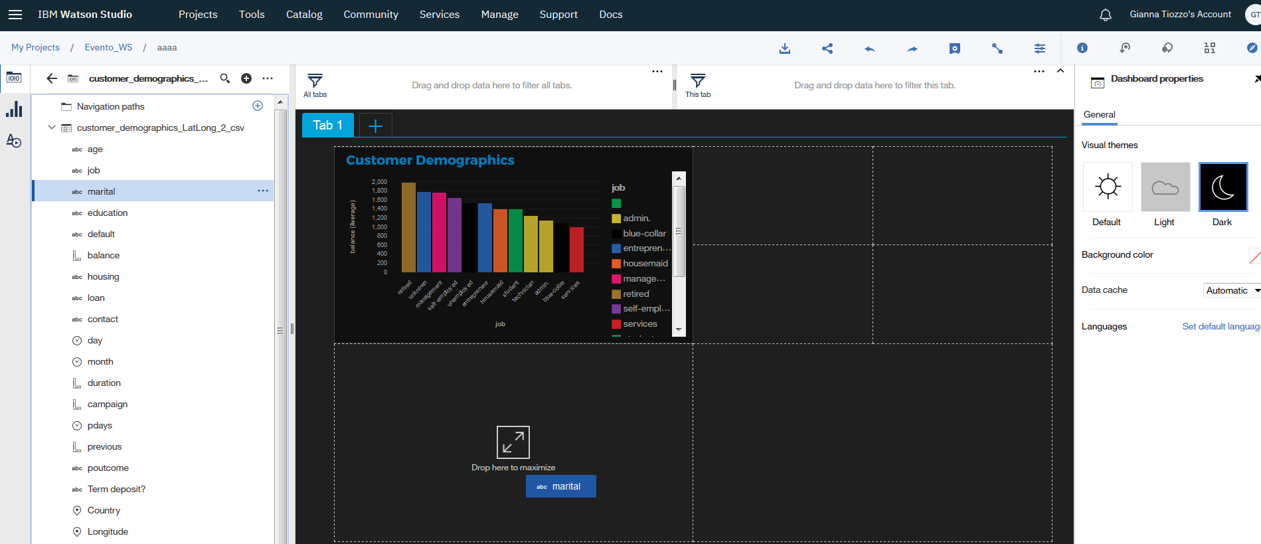
2. Let's customize the visualization. I chose a **Pie Chart** for representing the different categories (summary ===> count) of the columns data. I chose to color the chart by marital data as well, a differnt color for each category.  
   [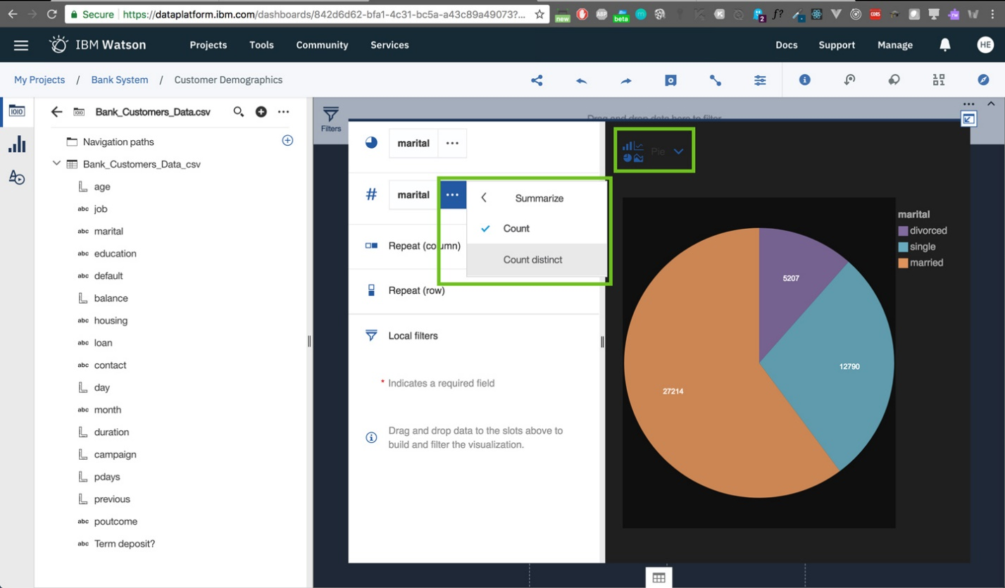](https://github.com/HebaNAS/IBM-Watson-Studio-Enablement/blob/master/06-CustomerDemographicsDashboard/imgs/28.jpg?raw=true)
3. Select Visualization properties and change palette color and Donut Radius

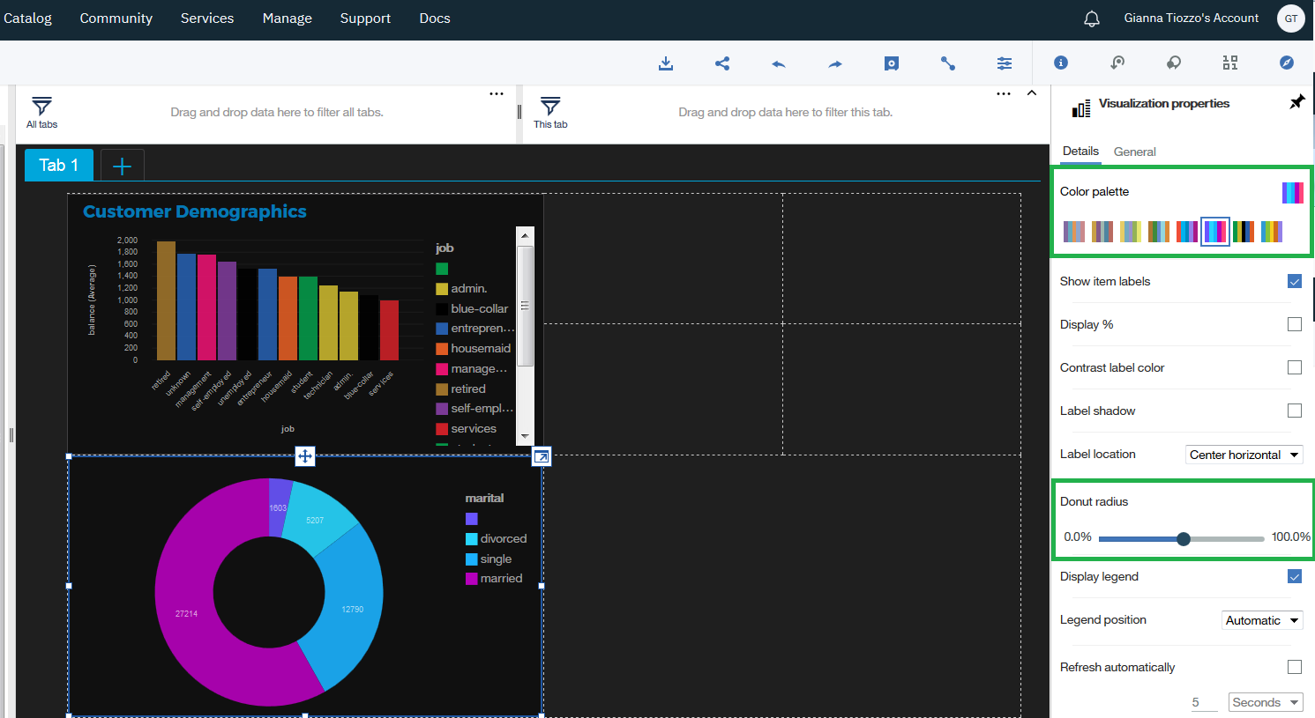

1. Drag Balance and Campaign in the template

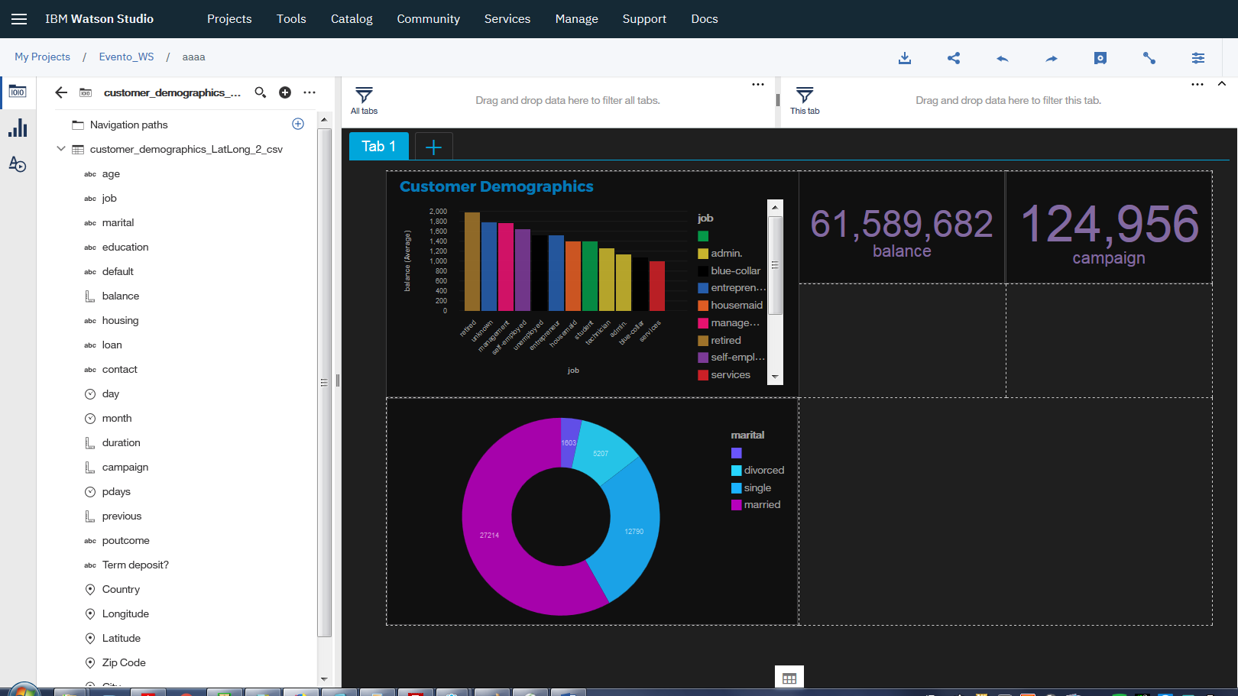

1. Change format of Balance and Campaign

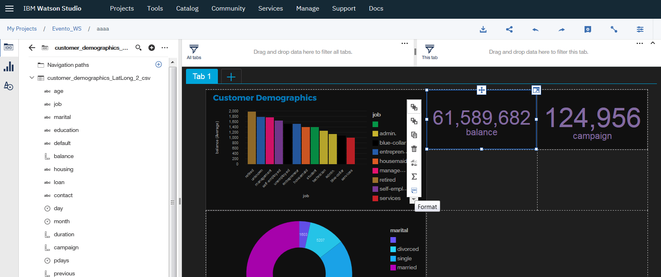

1. And select “Abbreviate”

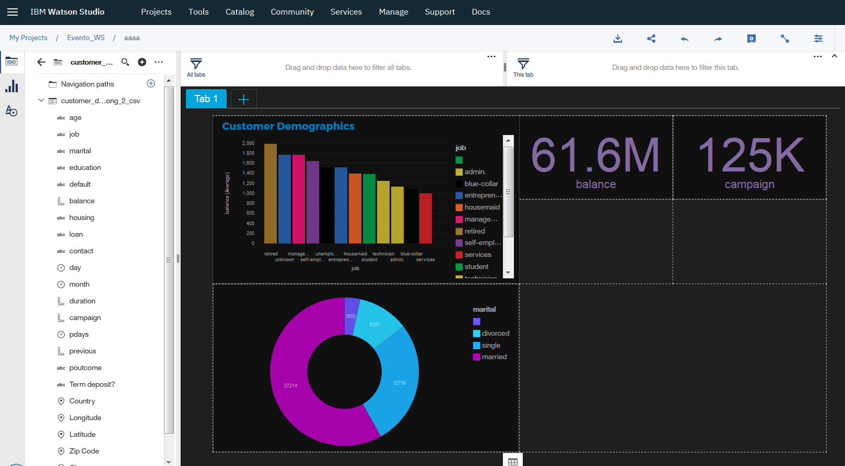

1. And add other visualizations

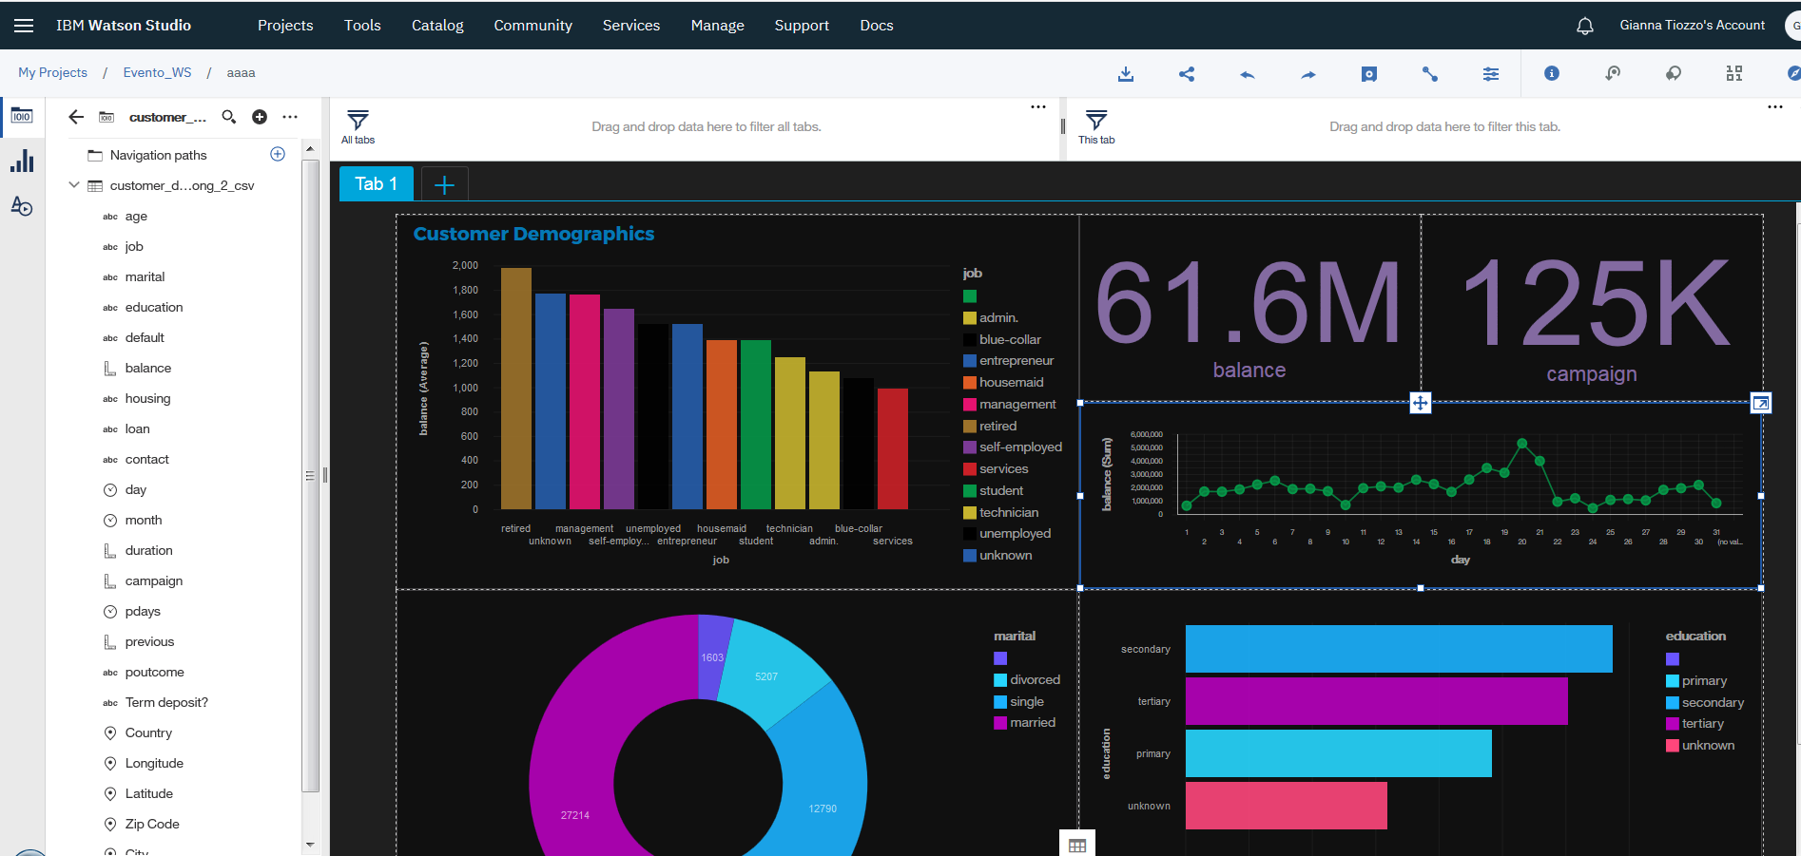

1. Rename the tab “Tab1” as “Customer Demographics”

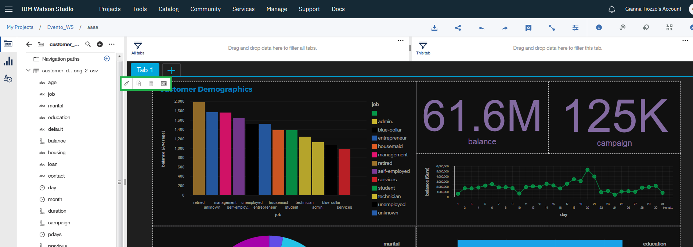

1. Add a new tab “Customer Geographics”

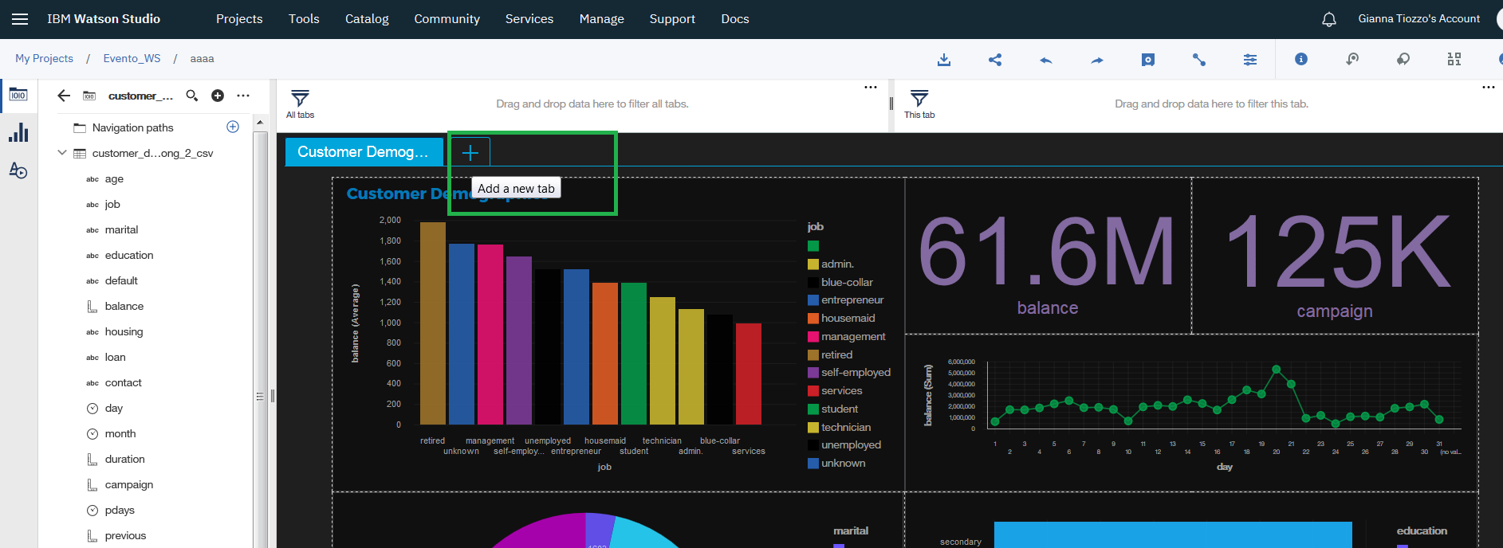

1. And select this template 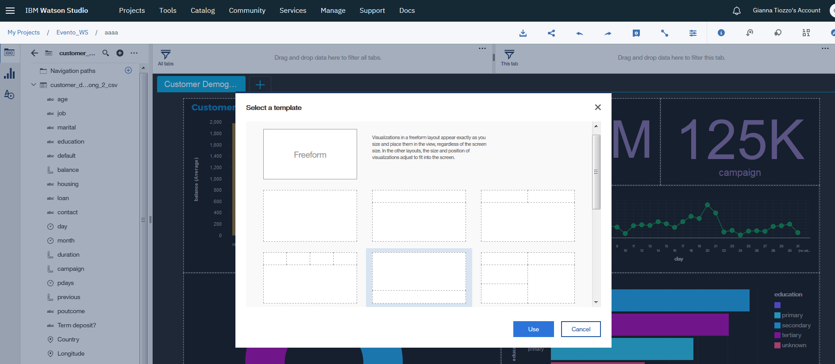
2. Drag Balance and City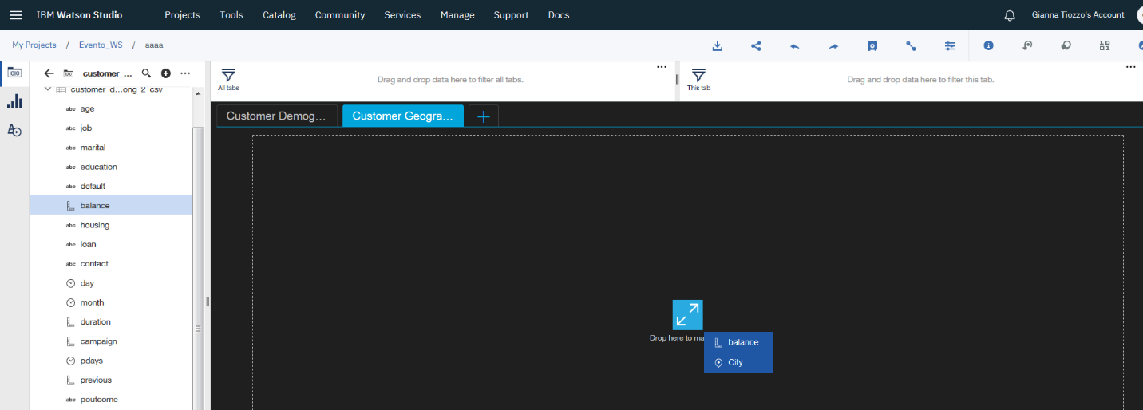
3. And You can see

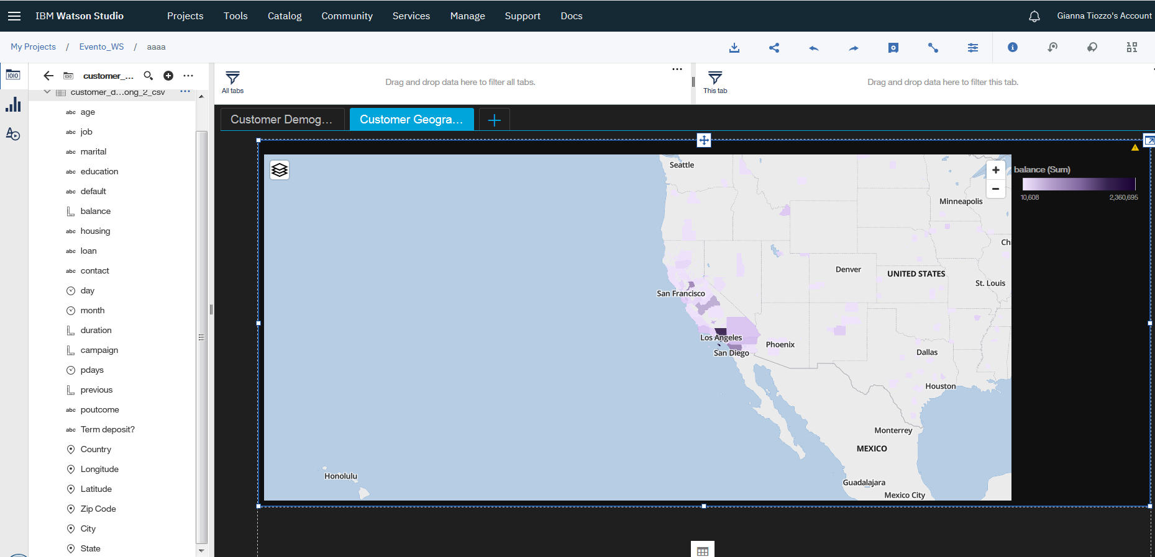

1. And you can set latitude and longitude

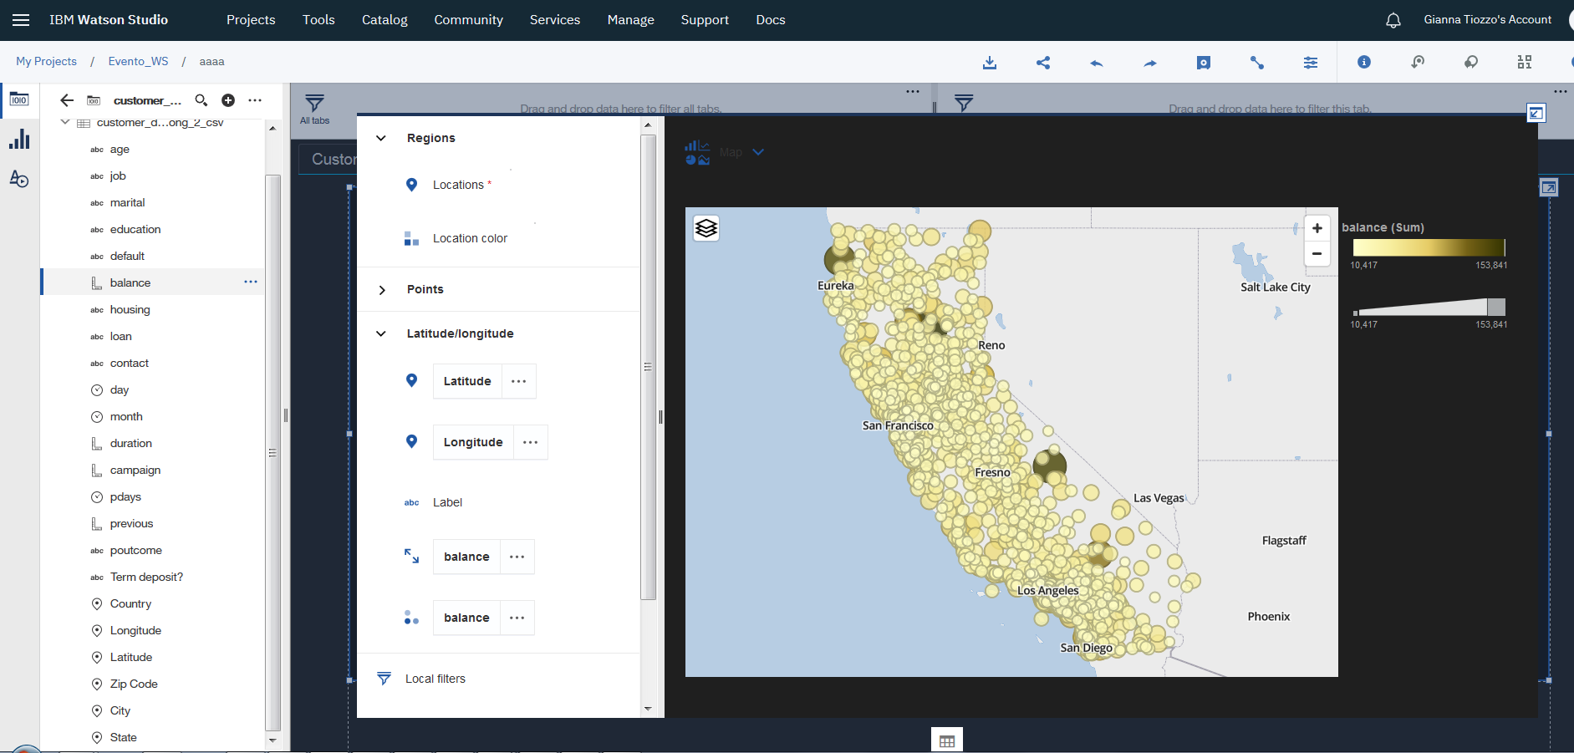

1. And you can change color palette

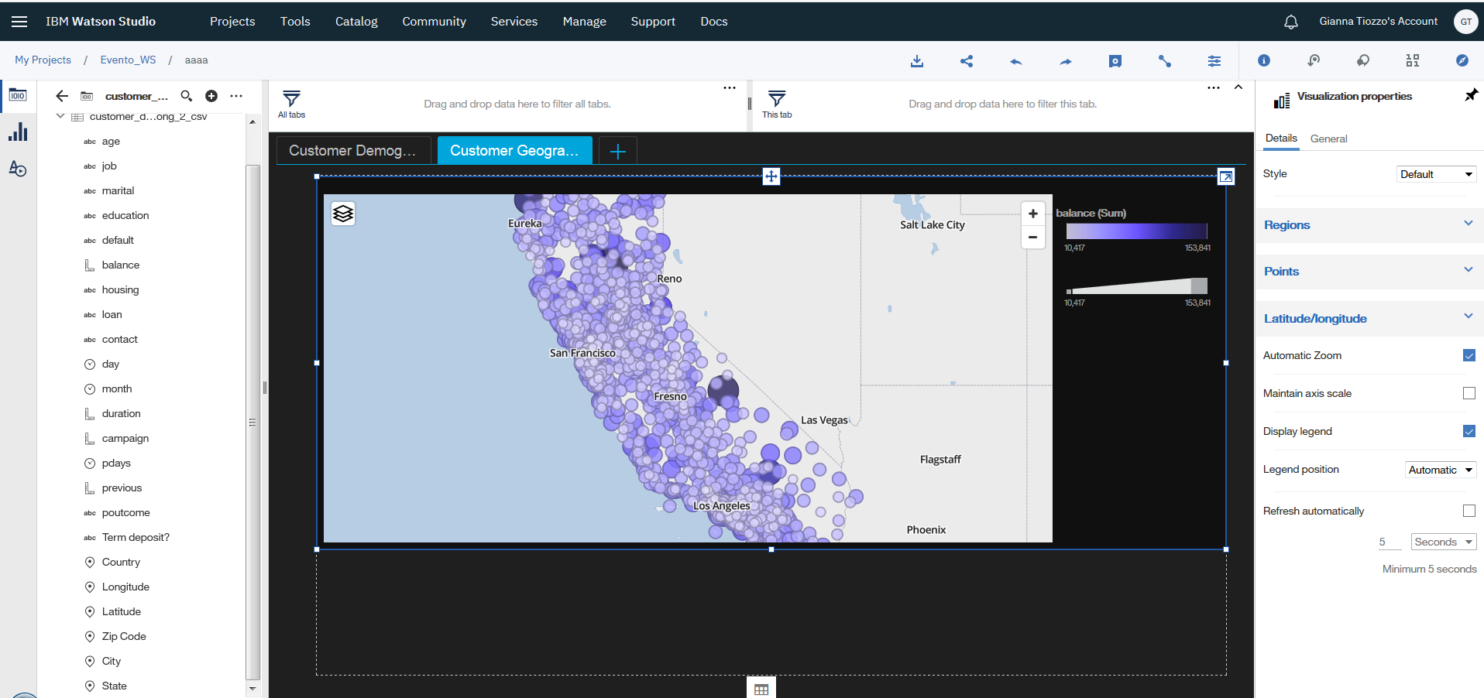

1. Drag Data Player from left – panel 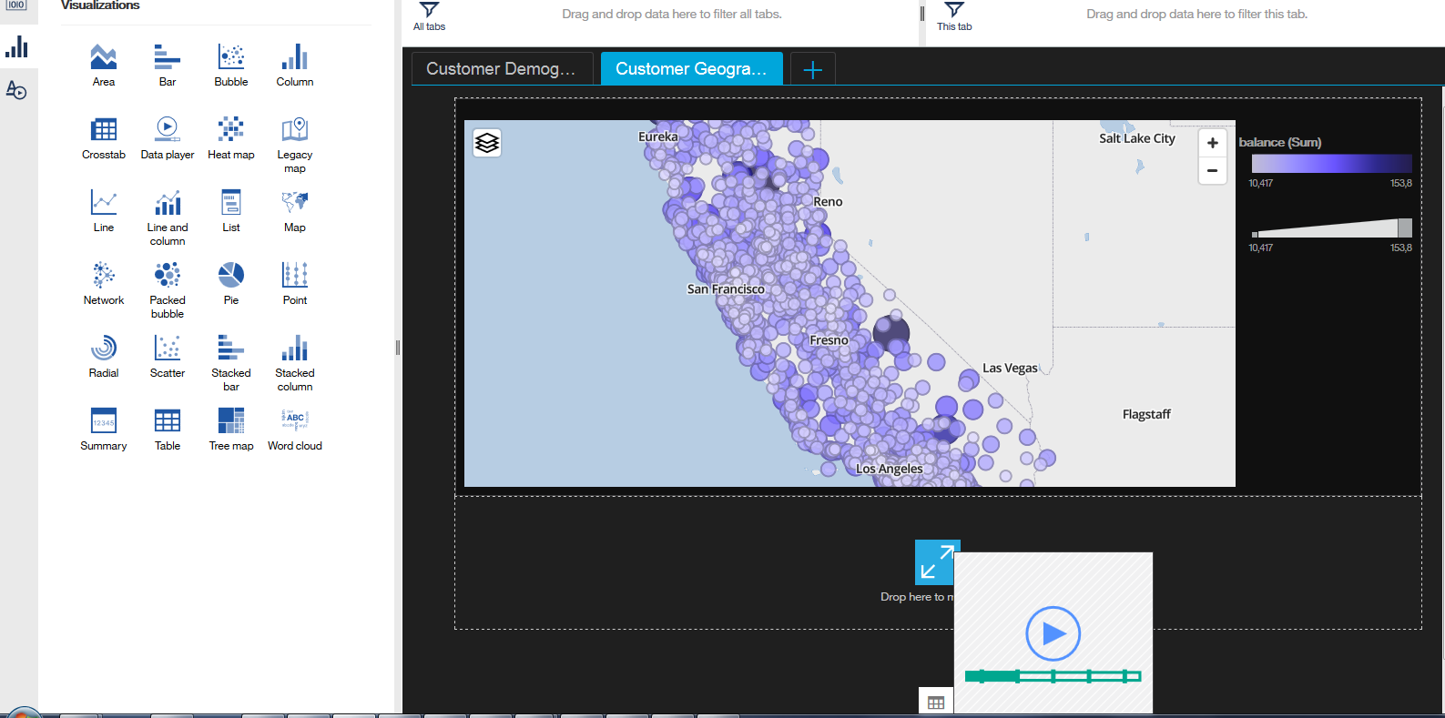
2. Drag day to Axis Label

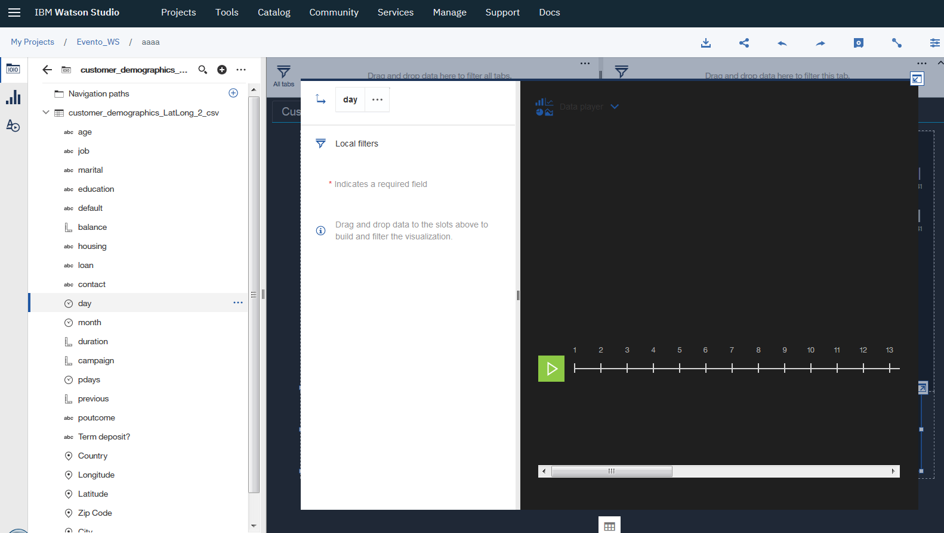

1. Click on  to start automatic filter
2. Click on save to save the dashboard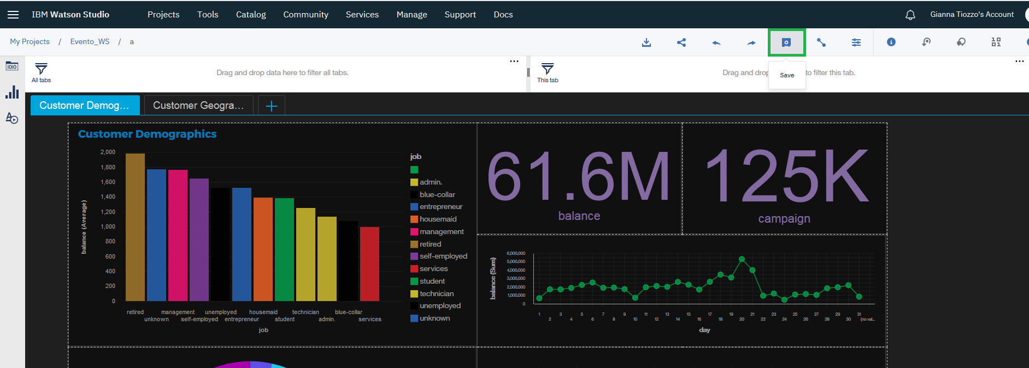
3. You can share the dashboard

[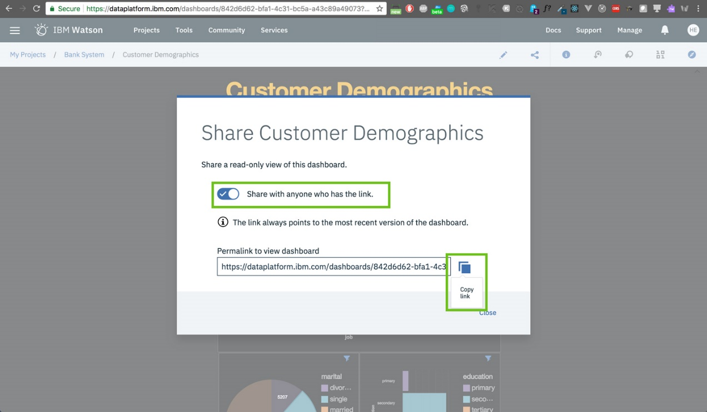](https://github.com/HebaNAS/IBM-Watson-Studio-Enablement/blob/master/06-CustomerDemographicsDashboard/imgs/30.jpg?raw=true)

1. All visualizations are interactive!